Assignment #3
Question #1
The designer of an adventure game wants a player to be able to take various items found in the rooms of the game. Two of the items found in the game are bags and boxes. Both bags and boxes can contain individual items (money, tokens, and food) as well as other bags and boxes. Bags and boxes can be opened and closed, and items can be added to or taken from a bag or box.
- (15 points) Which GoF design pattern might be a good choice for the above problem? Briefly justify your decision.
Answer: I would go with the Composite pattern. Bags and boxes can contain items but also other bags and boxes, so it's basically a tree structure. Composite lets us treat a single item and a whole container the same way through a common interface, and the add/remove operations go on the container side.
- (20 points) Please provide a UML class model for the above file system problem and based on your answer in a.). Include operations and cardinalities based on the problem description
Answer:
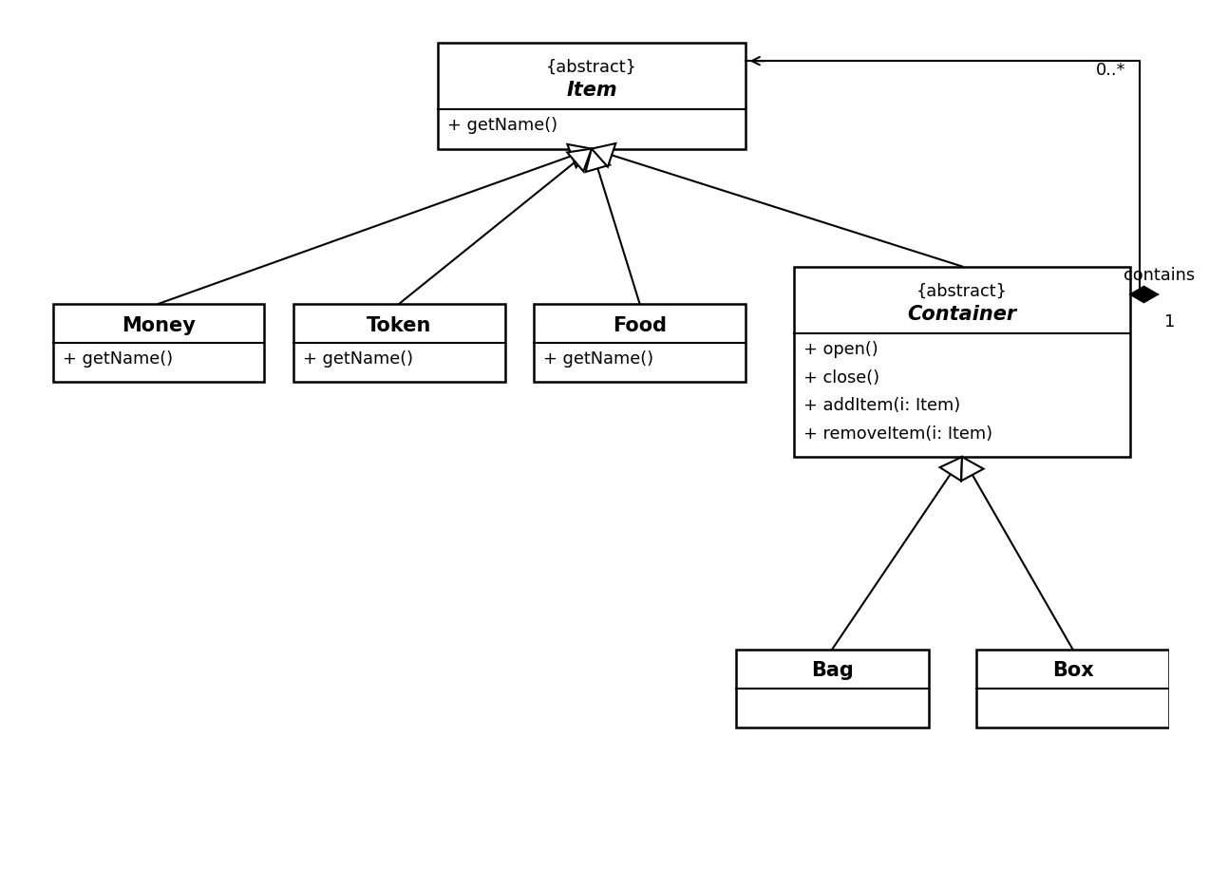

Question #2
Given is the following partial description of a COMP354 Word processor. Whenever the user types, the word processor should automatically updated information to the user, in the form of:
- The count of words that start with an uppercase letter in each line and displaying this information in the status bar of the word processor.
- Saving the typed lines of text automatically to a file.
- Display the number of words
- Display the number of characters
The design also should support the easy extension of the Word processor in the future to display additional. Possible new features related to the text currently typed could be, e.g. read-a-loud of letters each time a new character is entered.
- (15 points) Which of the GoF design patterns would be most applicable for this problem? Briefly justify your decision (2-3 sentences)
Answer: Observer pattern. The typed text would be the subject and the different features (status bar count, autosave, word/char count) are observers that get notified whenever the user types. It also makes adding new features like the read-aloud easy, you just add another observer.
- (20 points) Provide a UML class diagram for the above problem
Answer:
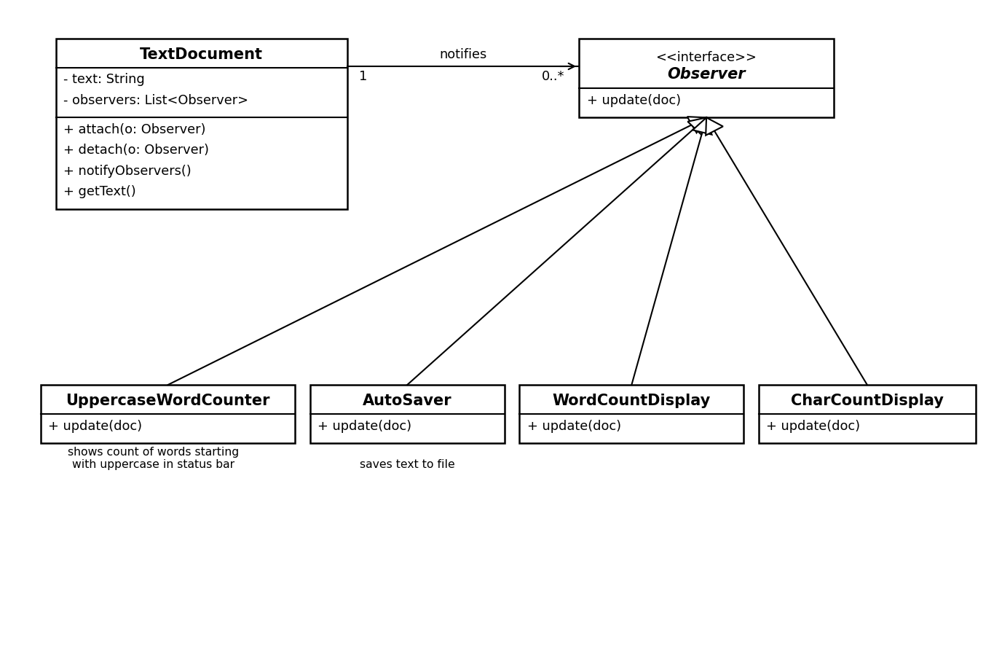

Question #3
You asked ChatGPT the following two questions: “What architectural style would fit best the following problem:
- (15 points) You are developing a new software system, which runs on a single machine, with no network connection and involves a set of independent components that are always executed in the same order, without any user intervention.
ChatGPT replies “a client server architecture would be best suited for the problem”
Do you agree / disagree and why?
Answer: Disagree. There is no network and everything runs on one machine, so client-server doesn't really make sense here. Independent components always running in the same fixed order sounds more like batch sequential (or pipe and filter).
- (15 points) You are developing a new software system, which is built upon central, persistent data managed by independent, active components across the continent that operate on this data.
ChatGPT replies “a client server architecture would be best suited for the problem”
Do you agree / disagree and why?
Answer: Disagree with this one too. Everything is centered around the central persistent data that the components operate on, which is the repository style. Client-server is more about clients making requests to a server, here the shared data is the main thing, so repository fits better.

